MS FRAM:

Northwest Passage - In the Wake of Great Explorers (Eastbound):
https://www.hurtigruten.com/destinations/northwest-passage/in-the-wake-of-great-explorers-eastbound-2019/

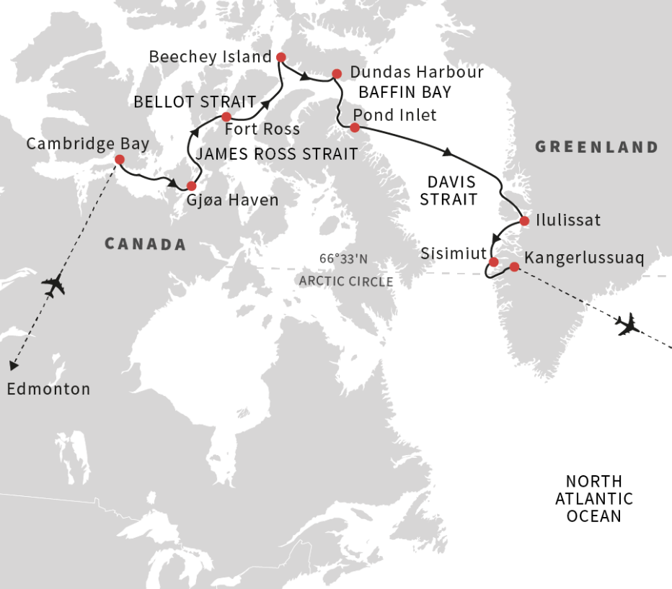

Northwest Passage: In the Wake of Great Explorers (Westbound):

https://www.hurtigruten.com/destinations/northwest-passage/the-northwest-passage-in-the-wake-of-great-explorers-westbound-2019/

