Tree River Geoscience Project 2022
Dr. Jesse Reimink

Project Location:
The area of interest is located within 100 km of 67°38'10.47"N, 111°54'7.00"W, which is the location of the Plummer’s Tree River Outpost fishing lodge.

Project description:
The proposed project consists of a collaboration between the University of Alberta, and the Pennsylvania State University. This project is focused on sample collection for various graduate student projects.

There will be three to five geologists and one float plane pilot staying at the Plummer’s Lodge on the Tree River and Kugluktuk, Nunavut. We will take day trips with a Bush Hawk float plane to nearby lakes (see map selection) where the geologists will use small rock hammers to take ~1kg rock samples for scientific research.

We will conduct field sampling of ancient basement rocks exposed on the surface. We will be residing at the Plummer’s Tree River Lodge and Kugluktuk for the duration of our project and will be flying a Bush Hawk float plane up to 100 km from this location during the day. We will land the Bush Hawk on small lakes, and hike to outcrops near the lakes. Once at outcrops of scientific interest, we will use small hand hammers to take geological samples for research (~1 kg samples) of the rocks of scientific interest.

We will be sampling for 12-15 days and expect to collect ~100 samples of rocks in this time period. The sampling will be spread out and will largely be focused on going back to sample locations that have been described by previous Geological Survey of Canada bedrock mappers, projects that took place in the 1980’s. Our crew will consist of three to five geologists and a float plane pilot.
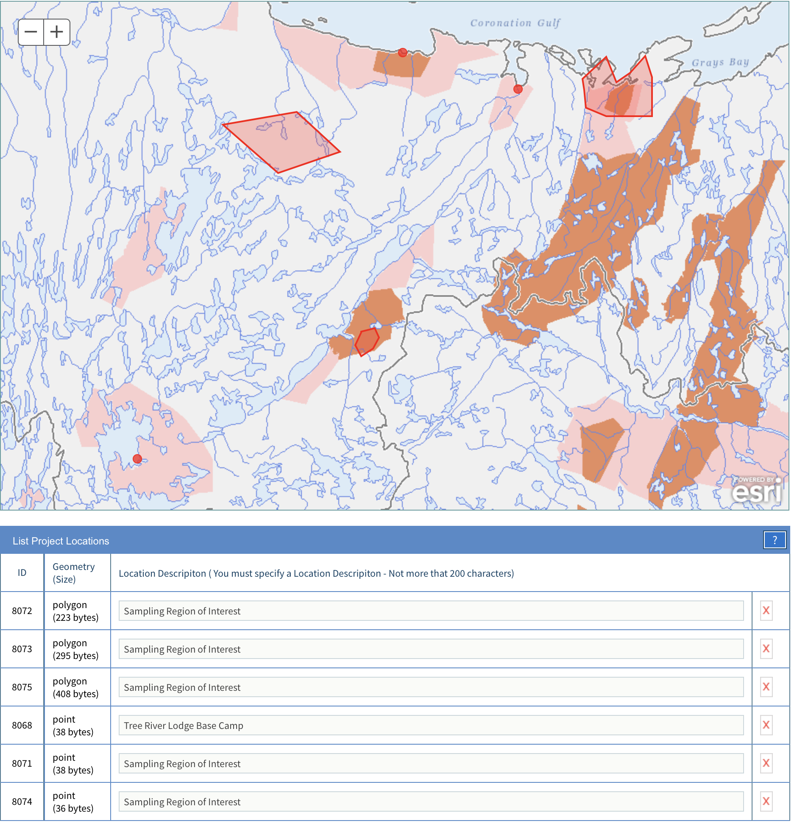
Water Use and Waste Management:
We will be staying at the Plummer’s Tree River outpost fishing lodge and be strictly following their water use and waste management protocols. No sewage will be released on site and no materials will be left on site.

Predicted Environmental Impacts:
The proposed fieldwork will not have any significant impact on wildlife or habitats
supporting wildlife. There will be no drilling or mechanical excavation. No power tool will be
employed for the collection and transportation of samples.

