REQUEST
FOR REAL PROPERTY SUPPORT
Exercises/Operations
RP OPs (North)
Submission Date | 2021-10-14
1. Name of Exercise or Operation | 2. Lodger Unit/Requesting Agency
Op Nanook-Nunalivut 2022 - Nunavut | JTFN

3. Op Planning PoC
Name | Rank/ Title | Phone number | Email
Morrissey | Capt | 867-873-0700 ext 6880 | lee.morrissey@forces.gc.ca

4. Location | 5. Municipality or nearest central node or hub
Yukon Territory | Cambridge Bay
Northwest Territories
X
Nunavut
Labrador
6. Multiple Sites
No

7. MGRS coordinates of Exercise/Operation, to pinpoint a specific location or
Op Box coordinates, for wider area of an Exercise/Operation
NW | 69 31 17.21 N 134 29 30.81 W
NE | 69 31 17.23 N 132 54 15.77 W
SW | 68 26 16.68 N 134 29 30.81 W
SE | 68 26 16.69 N 132 54 15.72 W
Additional A
Additional B
Google Maps coordinates or provide link to Google Maps map showing the Op Box
8. Overnight Stay
Yes

9. Activity
Commencement Date | People | Days
2022-02-16 | 50 | 11
Completion Date
2022-02-27

10. Occupation
Specific Intervals
11. Intervals (if applicable)
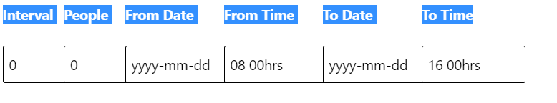
12. Specify your project type
A
A type projects - simple and short exercises without a camping component
B type projects - complex multi-day exercises or operations with camping component

13.1 For "A" type projects, please provide the Project Summary in the box below.
This should include a non-technical description of the project proposal (300 words max.),
outlining the project activities and their necessity, method of transportation, any structures
that will be erected, expected duration of activity and alternatives considered.
Ranger Patrol
15. Specify the mode(s) of transportation during this activity (e.g. Fixed Wing, Rotary Wing,
ATV, MOSV, LOSV, snowmobile or other)
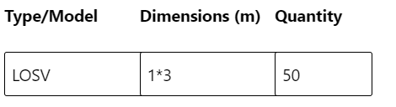
16. Is a fuel cache part of this activity?
Yes
17. If "Yes" to #16, provide the fuel type, amount stored on-site and method of fuel transfer
18. Specify the fuels to be used during this activity

19. Will equipment be used during this activity?
Yes
20. If Yes to #19, specify the equipment to be used during this activity
(e.g. power generators, tents, heaters, stoves, kitchen storage equipment, maintenance
shelter/facility or other)
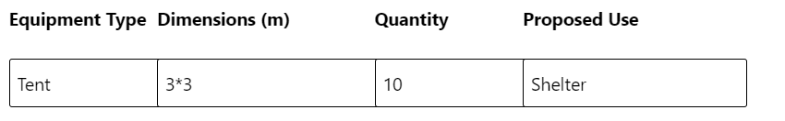

21. Are additional accommodations required for this activity? (i.e. facility rentals such as a hangar,
community hall, recreation centre, showers, laundry, hockey rink, private land access (outdoor camp)
or other))
No
24. Are pyrotechnics, explosives or ammunition to be used or discharged during this activity?
No
26. Is dud expected to be produced during the discharge?
No
28. Is water being drawn from site(s) during this activity?
No
30. Is waste and garbage (grey water/ sewage/ hazardous/ combustibles) being produced and deposited during this activity?
No

